INSTALLATION OF PYTHON 3.9.8

Date 25 october

Team ID PNT2022TMID28660

Project Name Smart Waste Management System For Metropolitan Cities

Step 1: Type python in google and click on the first link
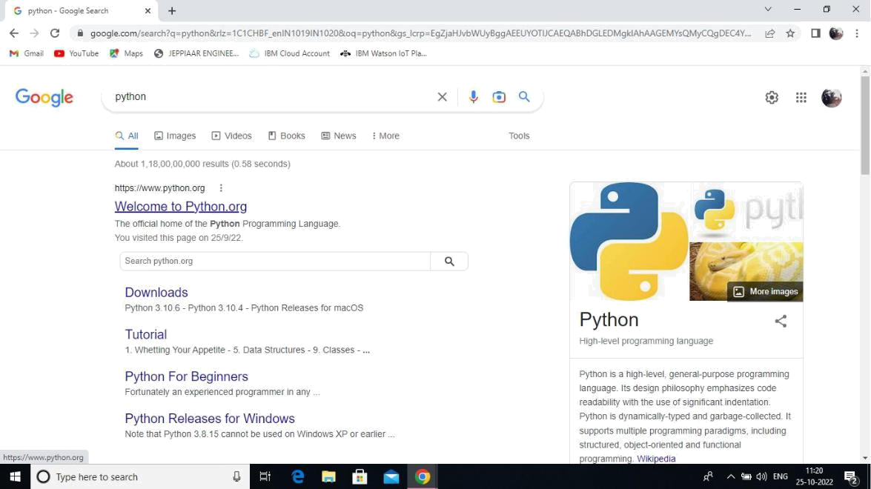


Step 2: Click the python 3.9.8

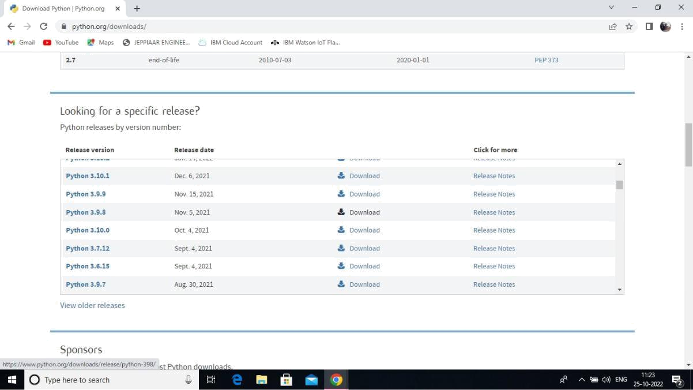

Step 3: Scroll down to reach Files and click on “Window installer (64 bit)

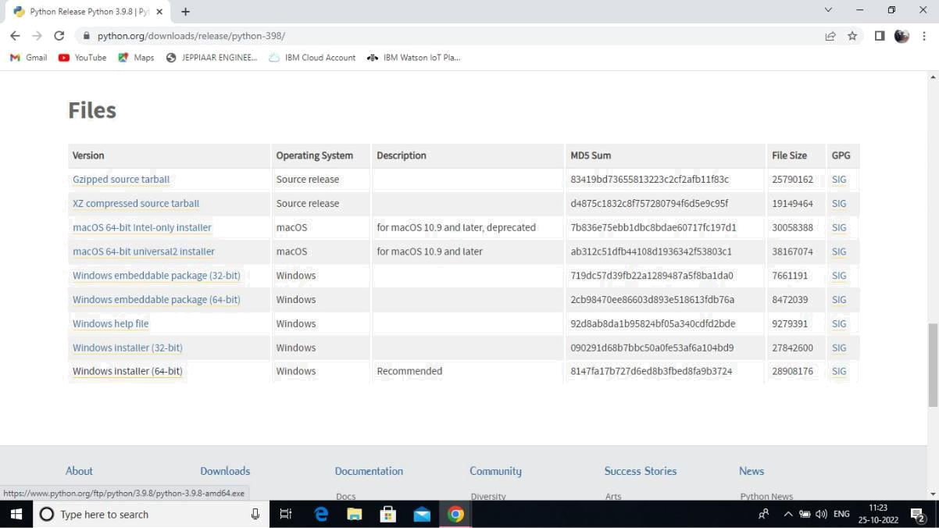

Step 4: Click on the Install button.
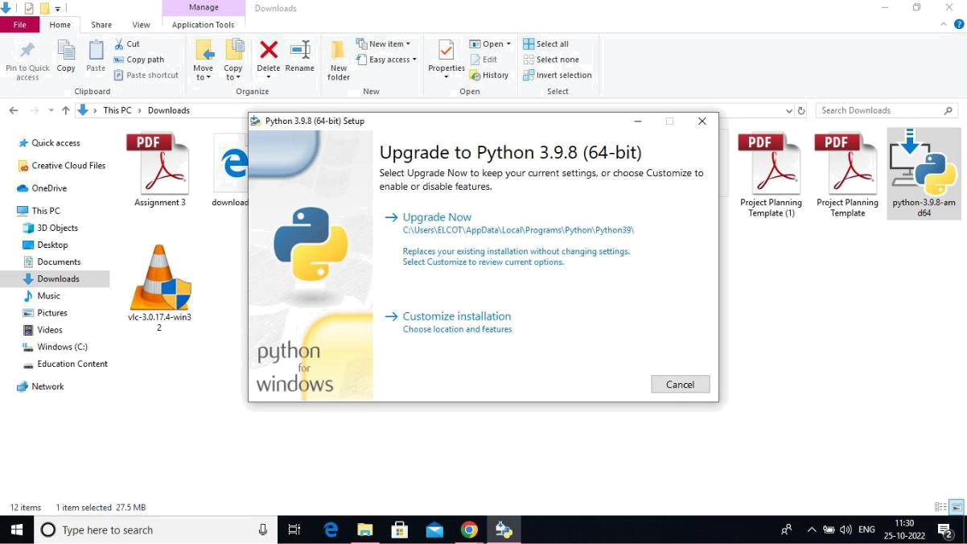

Step 5: Installation on progress
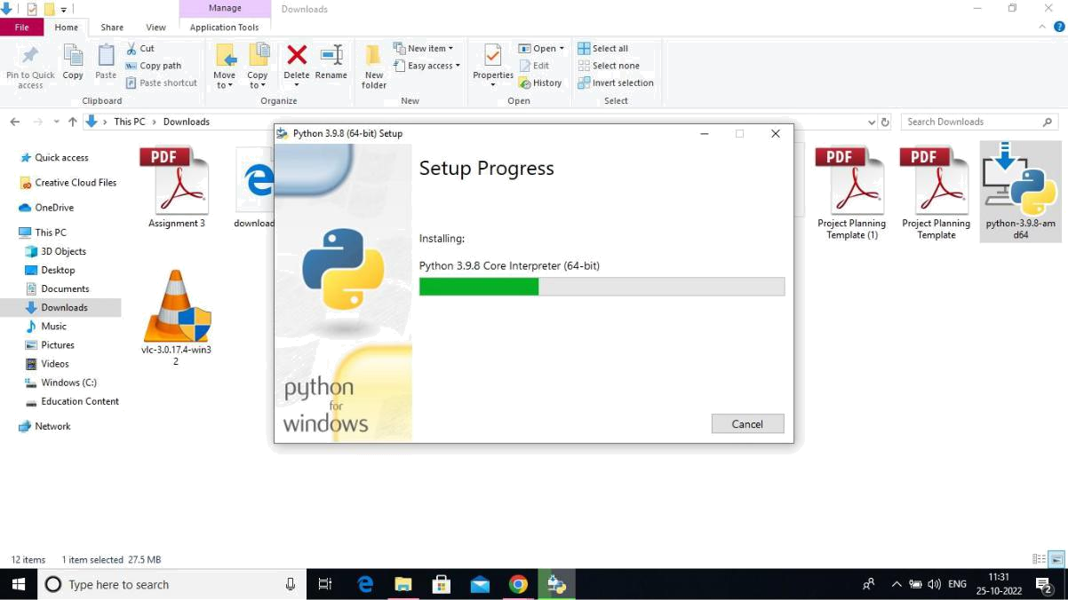

Step 6:Close the button

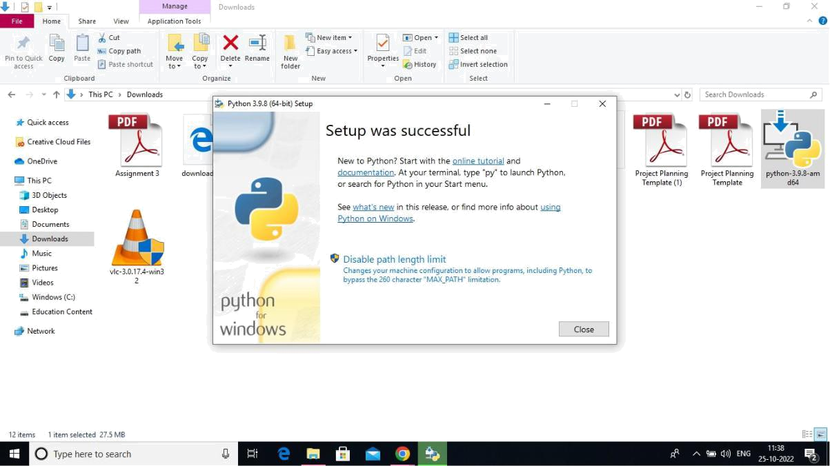

Step 7: Search IDLE
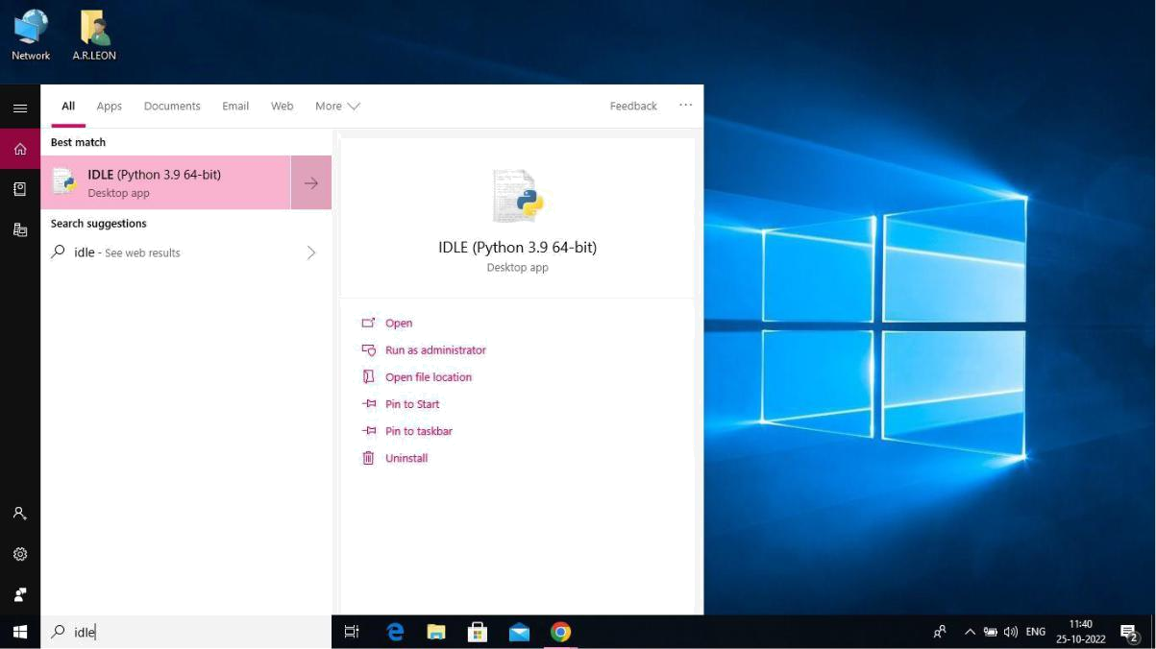

Step 8: Open it

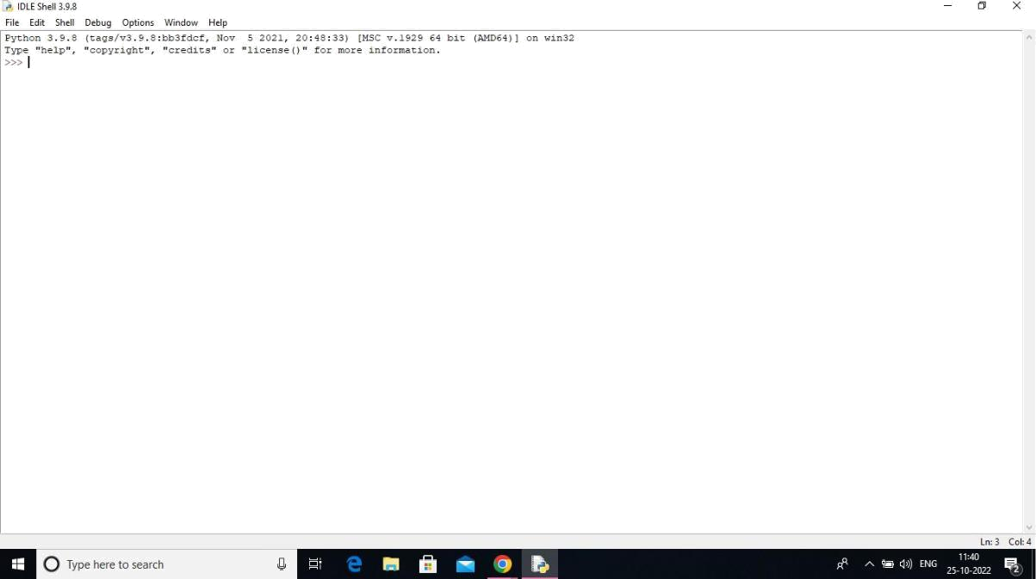

Step 9: Go to file and click on New File
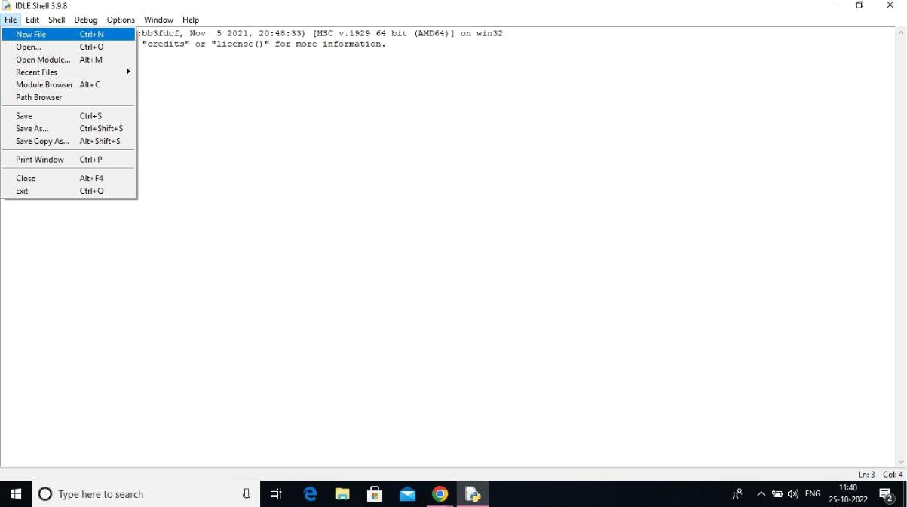

Step 10: Open it
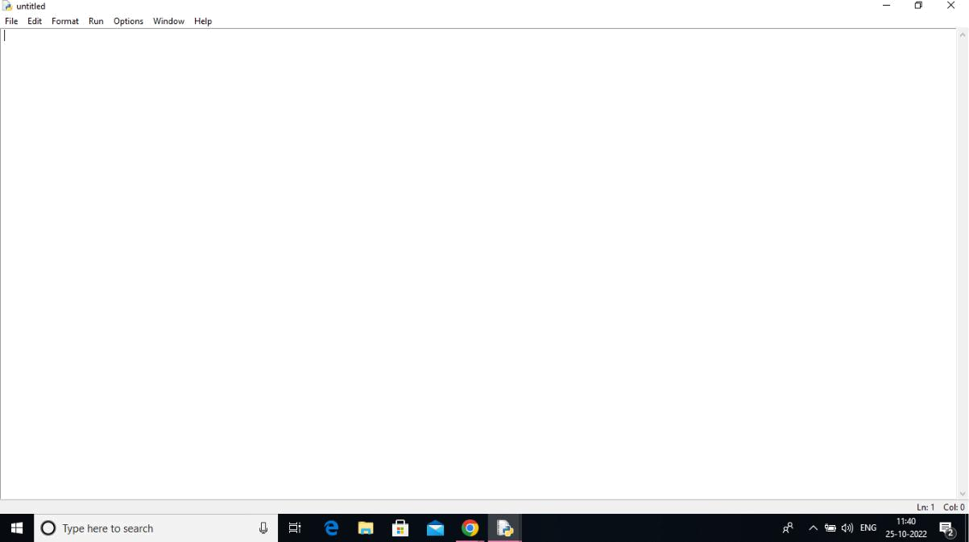

A Python 3.9.8 is installed successfully.

